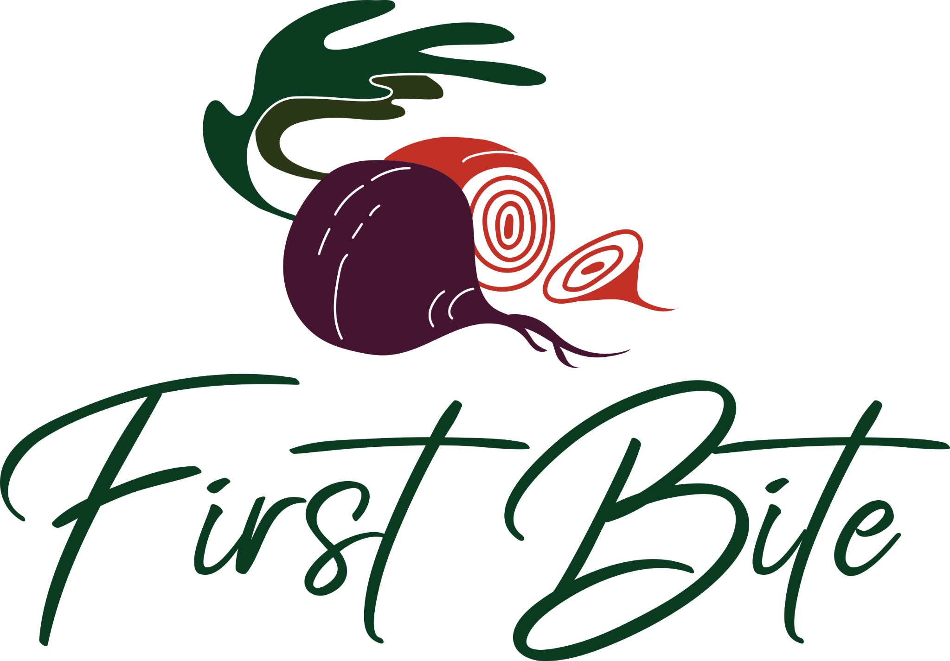

FIRST BITE 2023 SPONSORSHIP MEDIA KIT

First Bite is thrilled to have your support for our 18th year celebrating the booming Boulder dining scene. Our diners and restaurants are looking forward to 10 days filled with unique dining experiences offered throughout the Boulder County community - and with your help, we know it can be a big success.

Sponsors:
As a sponsor*, here is how we will promote your business:
- Social Media posts (Facebook, Instagram, Twitter/X)
- Exposure in our promotional e-newsletter
- Recognition in First Bite marketing materials, website, and promotional emails
* Please refer to your sponsorship agreement for precisely what is covered per your sponsorship level.

Here is how you can help promote First Bite:
Post about the event on your social media accounts! We have some examples below depending on the platform you are using, but feel free to use your own. Please don’t forget to tag @savor.prouctions on posts and stories so we can share and create even more engagement for you.

EVENT DATES
Friday, October 20 - Sunday, October 29, 2023
Specials will be available at the 25+ participating restaurants throughout this 10-day event. Please see our website for details.

WHEN TO START POSTING AND WHY:
Feel free to post about First Bite immediately! Consider posting once now, once in mid-October, and then again during the 10-day event Oct 20 - 29, reminding your audience that the First Bite event is happening so they don’t miss out. We encourage you to promote your participation and sponsorship and the restaurants you plan to visit throughout the event. Tagging our page, @savor.productions, along with other local businesses, increases reach and maximizes engagement. This is great for community building and a fresh way of getting your brand’s name out there as well!

IMAGES TO USE:
Find the high-res versions of these graphics attached to the email where you received this document, in Google Drive, or on the First Bite website in *LINK*

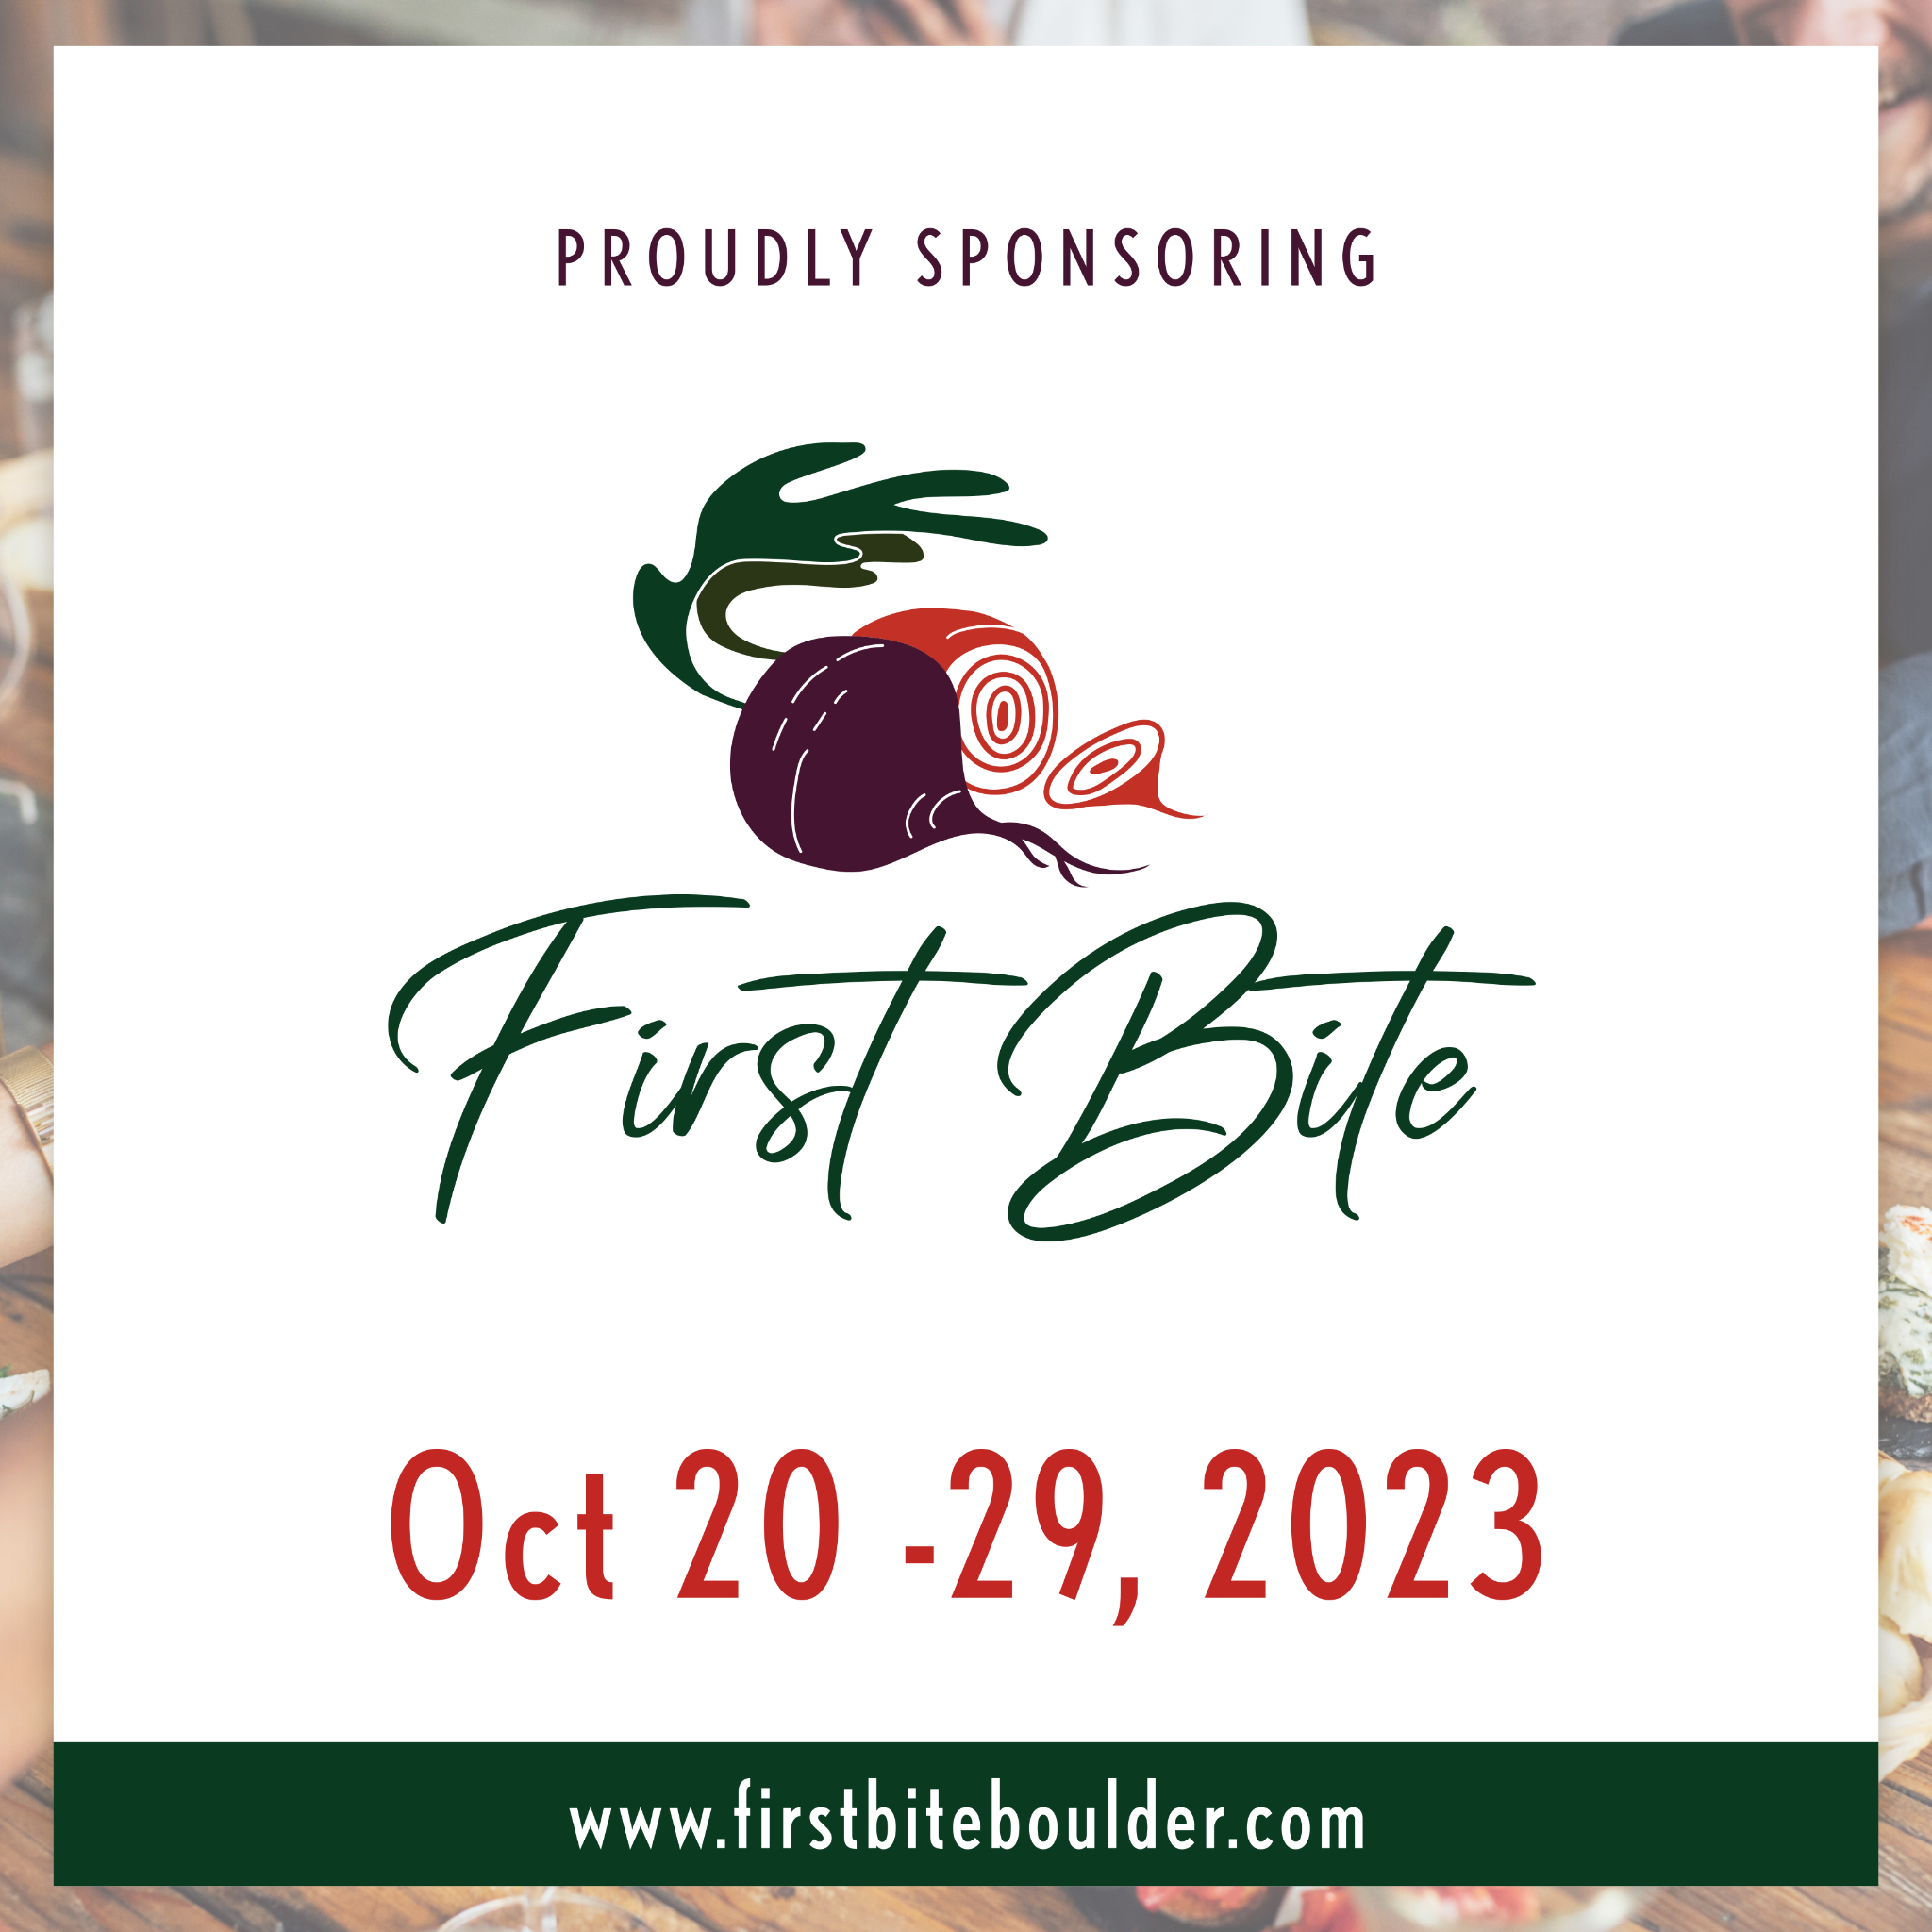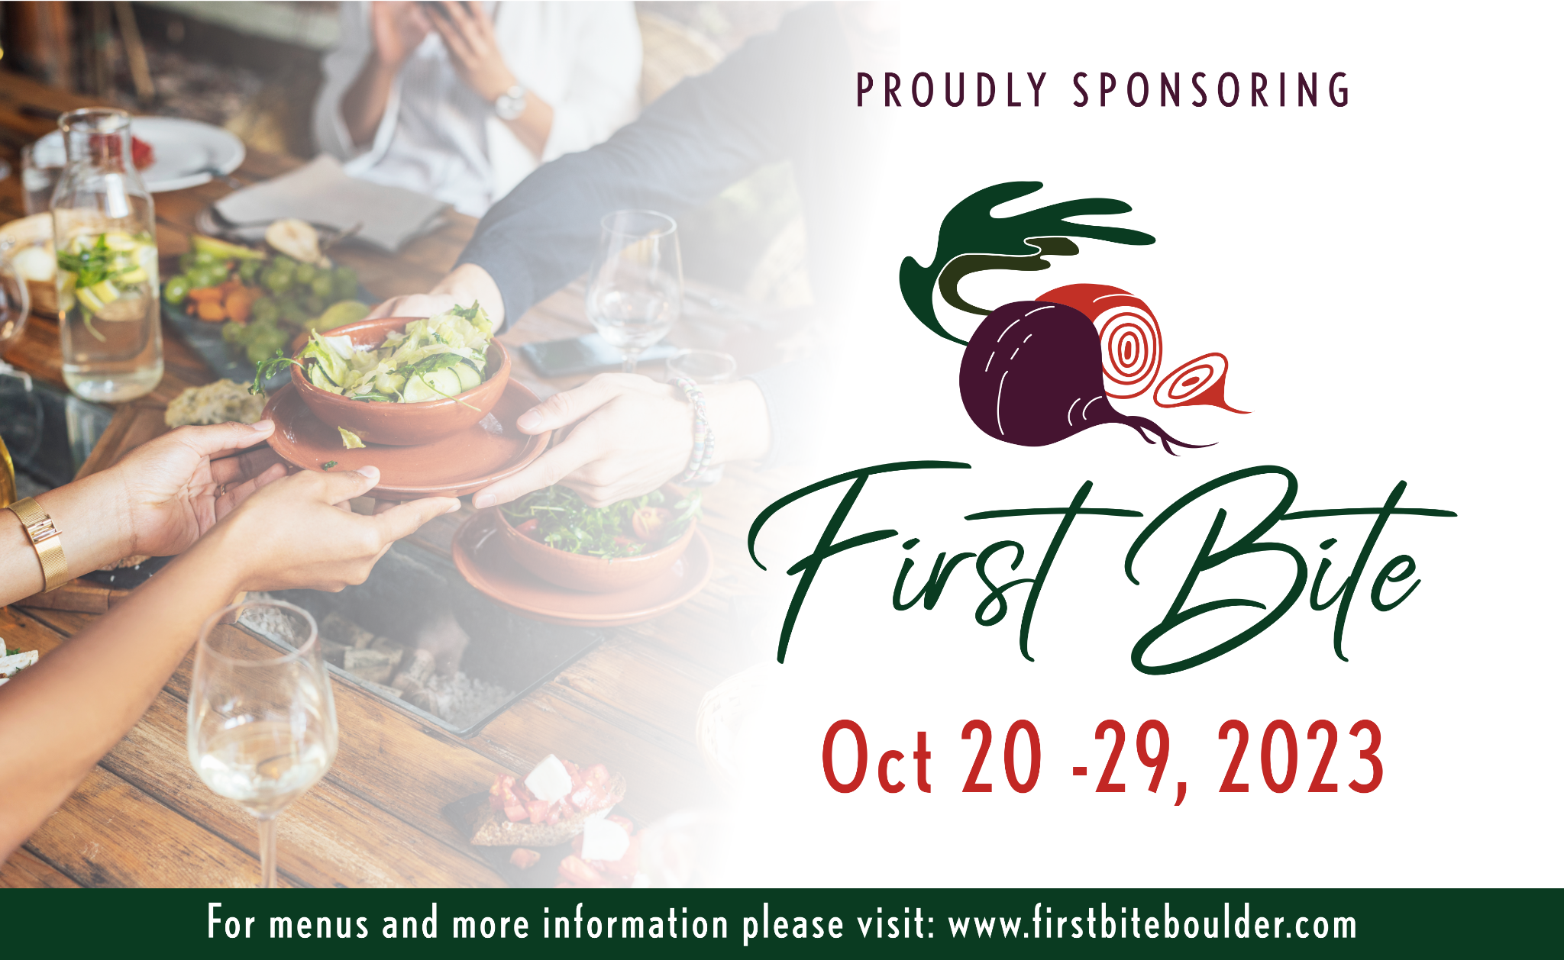

FACEBOOK POSTS (feel free to adapt for your own use)

First Bite is just _____ weeks/days away! Join us as we celebrate Boulder County’s vibrant dining scene showcasing top restaurants ranging from established favorites and new-to-town eateries. First Bite has evolved to include fresh menus and new offerings from Boulder’s most creative chefs. Save the dates October 20th - October 29th and see which businesses are participating at firstbiteboulder.com

---------

Grab your calendar and start planning out your 10-day tour of Boulder County’s best restaurants! From October 20th - 29th, check out one-of-a-kind dining experiences during First Bite! We proudly support our local community through this incredible restaurant industry-focused event. Like @savor.productions to stay up on the latest and see who’s participating at firstbiteboulder.com

---------

We are proud to support First Bite, their 18th annual celebration of Boulder County’s dining scene happening October 20 - 29. Join us at _________(a participating restaurant). Can’t wait to see you there! Like @savor.productions to stay up on the latest and click here to see a full list of participating businesses firstbiteboulder.com

---------

Hey, foodies – we want to hear from you! Which participating restaurants are you most excited to visit during First Bite? Sponsored by __________________(name of your business).

INSTAGRAM POSTS (feel free to adapt for your own use)

Possible hashtags to use
#firstbiteboco #firstbite2023 #boulderco #bouldercounty #boulderevents #bouldercolorado #boulderlocal #lovethelocal #restaurantrockstar #longmontcolorado #niwotcolorado #lyonscolorado

First Bite is just _____ weeks/days away! Join us to celebrate Boulder County's extraordinary dining scene with ten days of special menus at participating restaurants happening October 20 - 29. Follow @savor.productions for all the details.

---------

Head in and raise your fork from Oct 20 through Oct 29! We are proud to sponsor First Bite’s 18th annual celebration of Boulder County’s dining scene. Follow @savor.productions for all the details.

---------

Grab your favorite foodie for 10 great days exploring the vibrant dining scene around Boulder County. Check out one-of-a-kind menus and restaurant experiences during First Bite! We proudly support our local community through this incredible restaurant industry program-focused event. See who is participating by following @savor.productions.

TWITTER POSTS (feel free to adapt for your own use)

Join us as we enjoy First Bite’s 18th annual celebration of Boulder County’s dining scene happening Oct 20 - 29. Check out all the details at firstbiteboulder.com

---------

Celebrate Boulder County’s creative and unique restaurant scene during First Bite from Oct 20 - 29. Check out all the details firstbiteboulder.com

LINKEDIN POSTS (feel free to adapt for your own use)

Grab your calendar and start planning out your 10-day tour of Boulder County’s best restaurants! From October 20th - 29th, check out one-of-a-kind dining experiences during First Bite! We proudly support our local community through this incredible restaurant industry-focused event. See which businesses are participating at firstbiteboulder.com

