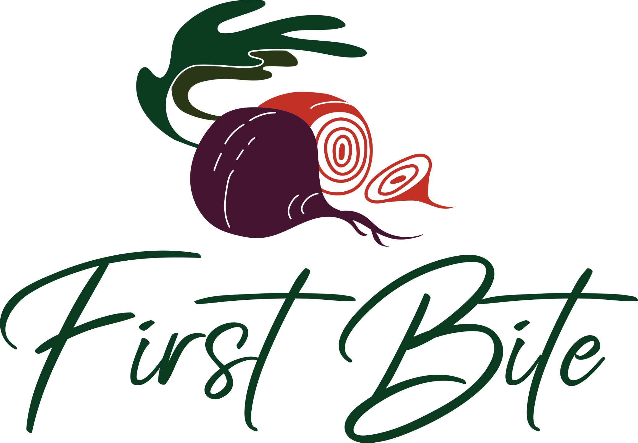

FIRST BITE 2023 PARTICIPATING RESTAURANT MEDIA KIT

First Bite is thrilled to have your participation in our 18th annual celebration of the booming Boulder dining scene. We are confident patrons are ready to enjoy 10 days filled with unique events and dining specials offered throughout the community - and with your help, we know it can be a big success!

Participants

As a participating venue, here is how we will promote your participation:
- Name listed on printed materials
- A dedicated web page on firstbiteboulder.com featuring your offering
- PR, social media posting, digital, print, radio, and television media
- Community outreach through local retailers, sponsor/partner organizations, and local influencers.

Here is how you can help promote First Bite:
Post about the event on your social media accounts! We have some examples below depending on the platform you are using, but feel free to use your own. Please don’t forgebt to tag @savor.productions on posts and stories so we can share and create even more engagement for you.

EVENT DATES
Friday, October 20 - Sunday, October 29, 2023
Specials will be available at the 25+ participating venues throughout the weekend. Please see firstbiteboulder.com for details. If YOU are hosting a one-day-only event in addition to your First Bite specials, please be mindful of adding the specific dates and times to your post!

WHEN TO START POSTING:
Feel free to post about First Bite immediately! Consider posting once now, once in mid-September, and then again during the 10-day event Oct 20 - 29. This helps to remind your audience that the First Bite event is soon/happening so they don’t miss out on the fantastic experience you have worked so hard to create. You can post frequently to promote your menu and specials throughout the event.

IMAGES TO USE:
We strongly encourage you to showcase your menus!! Share images of your food, your staff(see below for more on this), and your unique experience! Our audience is hungry (pun intended) for real photos of your offerings - serve it up!

We’d also love for you to share our logo on your feed to showcase your involvement. Find the high-res versions of these graphics attached to the email where you received this document, on Google Drive, or on the First Bite website in Media Kit Images.

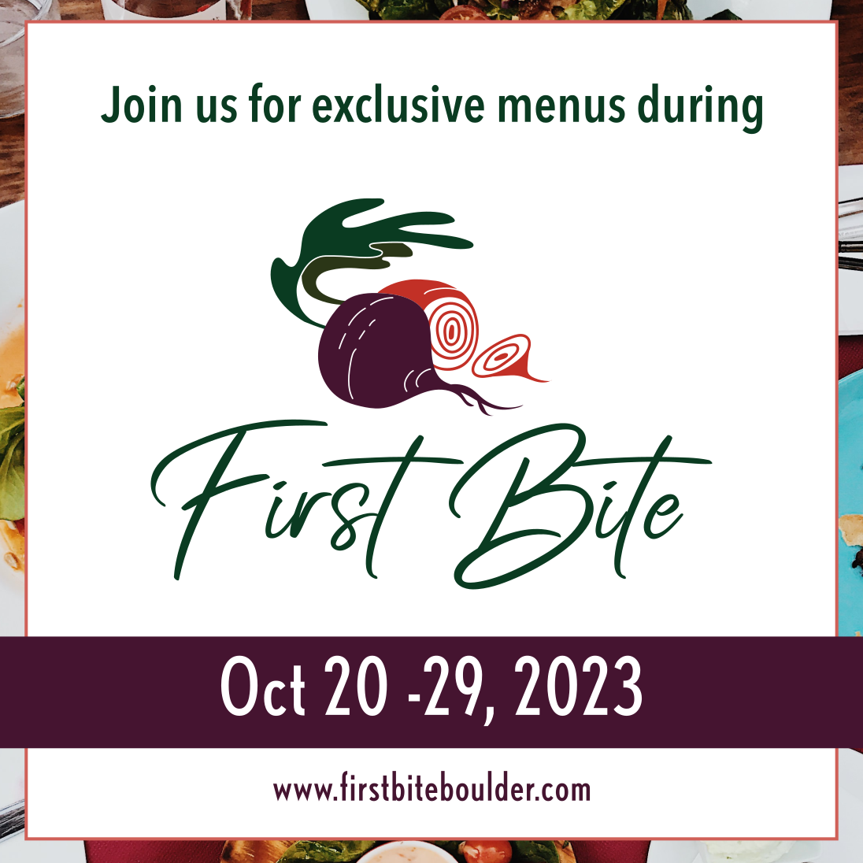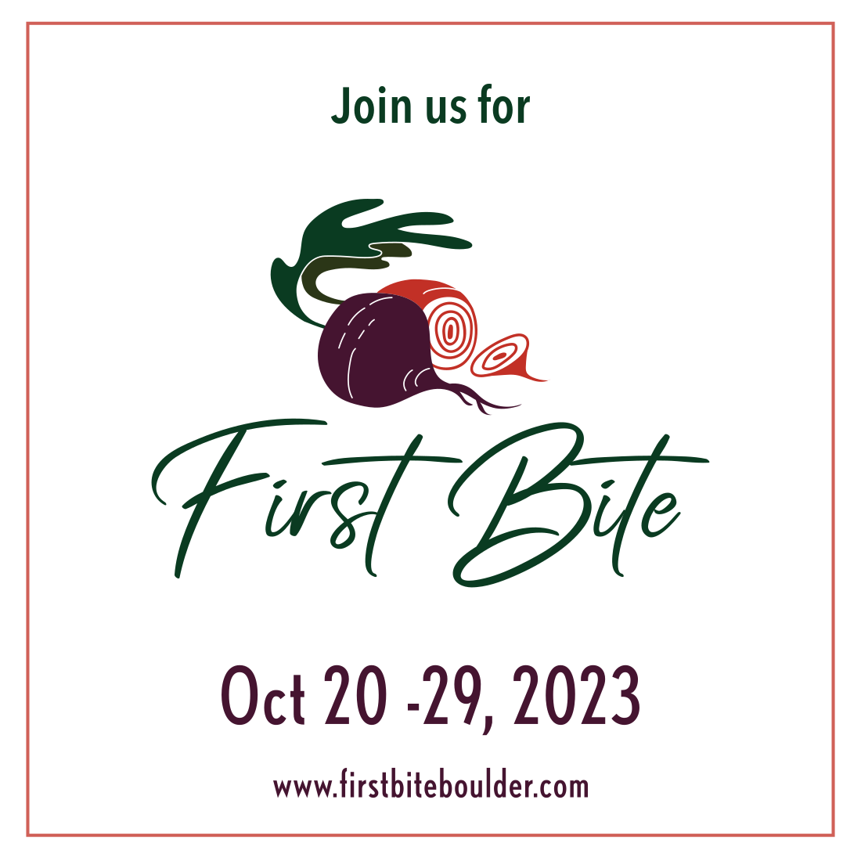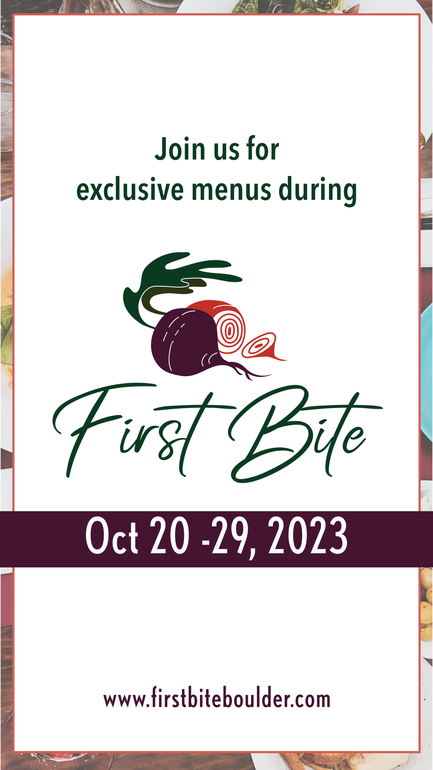

FACEBOOK POSTS (feel free to adapt for your own use)
Remember to include eye-catching visuals of your dishes, restaurant, and event logo to make these Facebook posts even more engaging and appealing to your audience.

Announcement:
We're thrilled to announce that _____________ (your restaurant name) is going to be a part of the 18th annual First Bite happening from October 20th to 29th! Join us as we present a special menu crafted just for the occasion. Save the date, stay tuned for updates, and head to firstbiteboulder.com for even more details!

Sneak Peek:
Our First Bite menu is taking shape, and we can't wait to share it with you! (Describe your special offering). Swipe through for a sneak peek at some of the delicious dishes that will be gracing our tables from October 20th to 29th. Trust us; you won't want to miss this! Learn more about the event at firstbiteboulder.com
First Bite | October 20-29, 2023

Reservations:
The countdown to First Bite has begun, and our tables are filling up fast! Don't miss your chance to savor __________ (your offer). Book now via our website or give us a call. Hurry, seats are limited!

Reminder:
First Bite is just _____ weeks/days away! Visit us between October 20 - 29 and celebrate Boulder County’s creative culinary scene by ordering our ______________ (your special offer). Click over to firstbiteboulder.com for all the details.

INSTAGRAM POSTS (feel free to adapt for your own use)
Remember to include eye-catching visuals of your dishes, restaurant, and event logo to make these Instagram posts even more engaging and appealing to your audience.

Use these hashtags
#firstbiteboco #firstbite2023 #boulderco #bouldercounty #boulderevents #bouldercolorado #boulderlocal #lovethelocal #restaurantrockstar #longmontcolorado #niwotcolorado #lyonscolorado

Announcement:
We're thrilled to announce that _____________ (your restaurant name) is going to be a part of the 18th annual First Bite happening from October 20th to 29th! Join us as we present a special menu crafted just for the occasion. Save the date, stay tuned for updates, and follow @savor.productions for even more details!

Sneak Peek:
Our First Bite menu is taking shape, and we can't wait to share it with you! (Describe your special offering). Swipe through for a sneak peek at some of the delicious dishes that will be gracing our tables from October 20th to 29th. Trust us; you won't want to miss this! Learn more about the event by following @savor.productions
First Bite | October 20-29, 2023

Reservations:
The countdown to First Bite has begun, and our tables are filling up fast! Don't miss your chance to savor __________ (your offer). Book now via our website or give us a call. Hurry, seats are limited!

Reminder:
First Bite is just _____ weeks/days away! Visit us between October 20 - 29 and celebrate Boulder County’s creative culinary scene by ordering our ______________ (your special offer). Follow @savor.productions for all the details.

TWITTER / X POST (feel free to adapt for your own use)

Join us October 20 -29 during First Bite! @savor.productions 18th annual celebration of Boulder’s dining scene. Check out all the details at firstbiteboulder.com or follow @savor.productions

Restaurant Rockstar Award:
Sponsored by Society Insurance

First Bite is dedicated to recognizing all the parts that make our vibrant restaurant scene incredible, and a large part of that is YOUR people. Boulder County is full of restaurant workers who consistently provide genuine hospitality, delicious food and hard work night in and night out.

This award honors restaurant workers who go above and beyond the job to deliver outstanding customer service or team support and positively influence the customer experience.

Please note:
- TWO awards will be presented, one for Front of House and one for Back of House.
- Only participating First Bite restaurants are eligible to win.

Encourage your staff and diners to nominate your FOH and BOH staff for their chance to win $250 cash + awesome prizes!

Nominations open: October 5
Nomination deadline: October 31
Winners announced: November 3

SUGGESTED SOCIAL MEDIA CAPTIONS (feel free to adapt for your own use)

They make it all happen! Our team's dedication deserves to shine. @savor.productions and @societyinsurance are looking for Restaurant Rockstars. Vote for one of our amazing servers and let's win this together! firstbiteboulder.com/restaurant-rockstars

—---------

Behind every memorable dining experience are the dedicated folks who make it happen. Our team at ________________ (your restaurant) is in the running for the Front of House and Back of House awards by @savor.productions and @societyinsurance! Vote now to help us recognize their outstanding contributions. Your vote could not only make them winners but also reward them with $250 cash and fantastic prizes. Let's give them the recognition they truly deserve! firstbiteboulder.com/restaurant-rockstars

